Text Analysis

A Project Report Submitted
for

Information Technology
By

Yash sharma
(Roll no. 35)

Under the guidance of
Mr. Praveen Kumar Joshi



EVER GREEN SENIOR SECONDARY SCHOOL
(GOVERNED BY EDUCATIONAL WELFARE SOCIETY)
TULARAMPUR - 263139, DISTRICT-NAINITAL
UTTARAKHAND, INDIA

OCTOBER, 2021

CERTIFICATE

This is to certify that the project entitled “Text Analysis” being submitted to Evergeen Senior Secondary School, Haldwani for the project work of INFORMATION TECHNOLOGY is a record of the work carried by MR. PRAVEEN KUMAR JOSHI under my guidance and supervision.

Date: Supervisor
MR. PRAVEENJOSHI
TGT Computer
Ever Green Sr. Sec. School, Haldwani
Forwarded By:
MR. M.S. PARWAL
Principal
Ever Green Sr. Sec. School, Haldwani

ABSTRACT
: Sentiment analysis or opinion mining is the computational study of people’s opinions, sentiments, attitudes, and emotions expressed in written language. It is one of the most active research areas in natural language processing and text mining in recent years. Its popularity is mainly due to two reasons. First, it has a wide range of applications because opinions are central to almost all human activities and are key influencers of our behaviors. Whenever we need to make a decision, we want to hear others’ opinions. Second, it presents many challenging research problems, which had never been attempted before the year 2000. Part of the reason for the lack of study before was that there was little opinionated text in digital forms. It is thus no surprise that the inception and the rapid growth of the field coincide with those of the social media on the Web. In fact, the research has also spread outside of computer science to management sciences and social sciences due to its importance to business and society as a whole. In this talk, I will start with the discussion of the mainstream sentiment analysis research and then move on to describe some recent work on modeling comments, discussions, and debates, which represents another kind of analysis of sentiments and opinions.

ACKNOWLEDGEMENT
I would like to express my most sincere heartfelt gratitude and respect to my supervisor MR. PRAVEEN JOSHI, for suggesting the topic for my project work and for his excellent guidance, valuable suggestions and endless support throughout for preparing the report. I am greatly indebted to him for his constructive suggestions and criticism from time to time during the course of progress of my work.
I would like to express my gratitude and sincere thanks to Mr. M.S. Parwal, Principal of School, and entire faculty who has imparted considerable knowledge to me.
Finally, I express my deepest gratitude to my parents for their continuous encouragement, understanding and support.

(Yash Sharma)

TABLE OF CONTENTS

Chapter | Topic | Page No.
 | CERTIFICATE
 | ACKNOWLEDGEMENT
 | LIST OF FIGURES
 | ABSTRACT
1. | INTRODUCTION
1.1 | SUB HEADING | 1-2
1.2
1.2.1
1.2.2
1.2.3
2.
3.
4.
4.1
4.2
4.3
4.4
5.
6. | SUMMARY AND FUTURE WORK | 16
 | REFERENCES | 17-18

LIST OF FIGURES

S.No. | Name | Page No.
1.
2.
3.
4.
5.

  - What is Text Analysis?

Text analysis, also known as text mining, is the process of automatically classifying and extracting meaningful information from unstructured text. It involves detecting and interpreting trends and patterns to obtain relevant insights from data in just seconds.
Let’s say your team needs to analyze hundreds of online reviews to learn about the things that your clients like or dislike about your product. Text analysis, however, can help you automatically tag reviews by topic and classify each opinion as positive, negative, or neutral, saving your team valuable hours.

Another term you may have heard is text analytics. While it’s closely related to text analysis, text analytics uses data visualization tools to transform insights into quantitative data while text analysis obtains qualitative insights from unstructured text.

  - How Can Text Analysis Help Your Business?
Companies deal with huge amounts of data every day, from emails, chats and social media posts, to customer support tickets, and survey responses. However, 80% of this data is unstructured and, therefore, hard to process – not to mention time-consuming if done manually.
Text analysis offers a solution to this problem.
It can help you automatically analyze customer feedback, like open-ended responses in CSAT surveys, so you can gain real-time insights that help you make improvements based on your customers’ needs.
If you receive a low CSAT score, for example, text analysis can be used to dig deeper into the reasons for these results, allowing you to know exactly what is going wrong. Maybe your customers prefer speaking to a real person instead of a chatbot, or maybe they were kept waiting too long before getting their first response. Knowing the why behind your stats and scores allows you to make smart decisions that increase customer satisfaction.
Businesses can also use text analysis to automate internal tasks that teams carry out manually. In customer service, for example, text analysis can help you automate your ticket tagging process and route tickets to the most appropriate agent. This makes companies more efficient, by saving agents valuable time and allowing them to focus on delivering better customer experiences.

2.Text Analysis Techniques and Examples

There are two main text analysis models: text classification and text extraction. Text classification involves assigning predefined tags or categories to a text, based on its content. Text extraction, on the other hand, is the process of extracting relevant information like keywords, company names, prices, and product specifications from unstructured text.
Discover more about the differences between text classification and extraction.

  - Text Classifications Applications
- Topic analysis: this text classification model identifies frequent themes or topics in a text. You can use a topic classifier to categorize incoming support tickets, product reviews, and NPS responses, among other types of text. For example, this product review would be tagged as Ease of Use:
“I love this app! It’s very intuitive: it took me just a few minutes to set it up”
Try out this NPS feedback classifier.
- Sentiment analysis: identifies the subjective information in a text and classifies opinions as positive, negative, or neutral. You can use it to analyze sentiments on Twitter, in customer support interactions, survey responses, and more, and get insights on how your customers feel about your brand.
Try out this free sentiment analyzer.

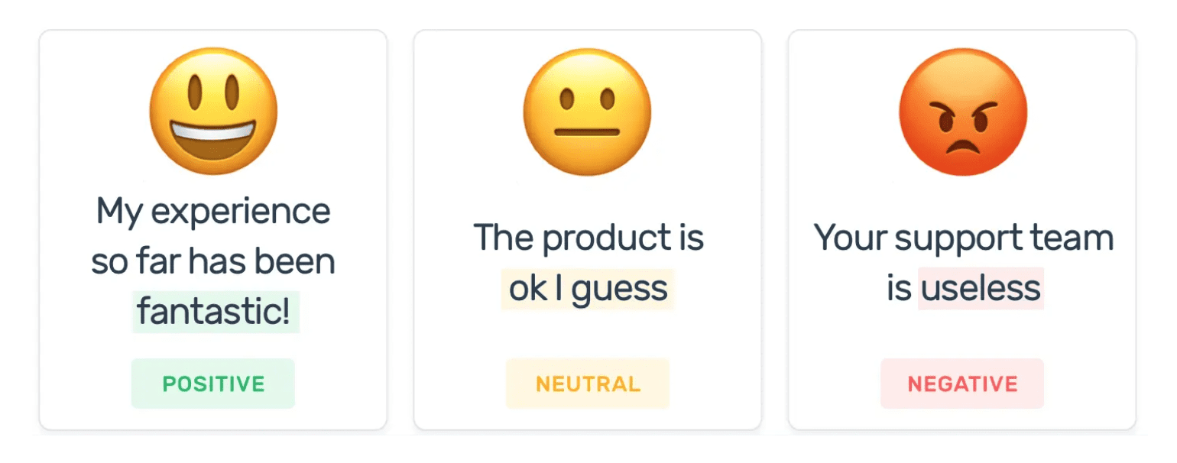

- Language Detection: A language detector automatically classifies a text based on its language. This can be very useful for ticket routing. For example, if you’re an international company you can route tickets to localized teams that understand them.

- Intent Detection: this classifier detects the intention behind a text, allowing you to take action immediately. For example, you might receive emails that request to unsubscribe from your product or a message that demonstrates an interest in your product. By classifying these into intents, such as Unsubscribe and Interested in Product, you can take immediate action.

  - Text Extraction Application
    - Keyword extraction: It consists of identifying and extracting the most relevant words and expressions in a text, providing you with a summary and insight about its content.
See how this keyword extractor pulls out keywords from a text:

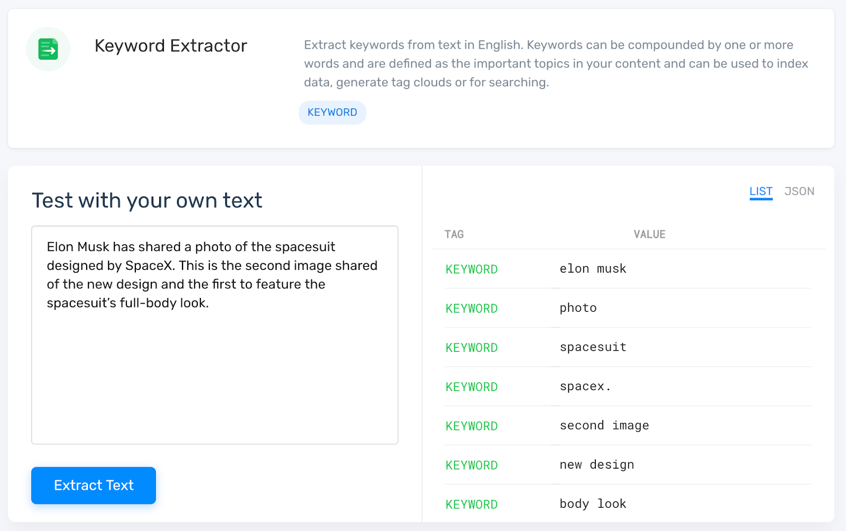

- Entity Extraction: entity extraction can help businesses collect important information, such as names, emails, phone numbers, and company names, or allow them to easily detect which of their branches are being mentioned more often. Try out this extractor that detects company names in text:

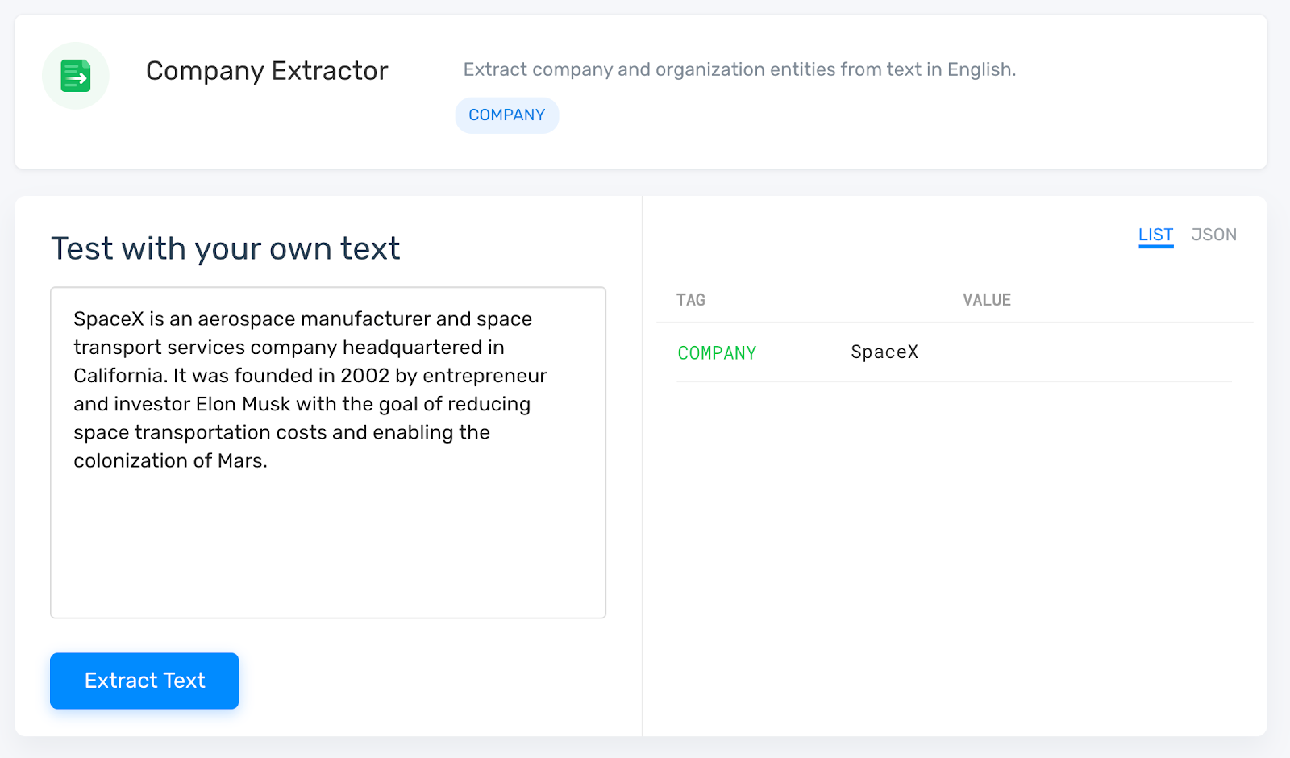

3. How to use an Online Tool for Text Analysis
Getting started with text analysis is not as difficult as it sounds. In fact, there are many text analysis tools that don’t require any programming skills to begin with.
MonkeyLearn is a no-code machine learning platform that hosts a range of pre-trained text analysis tools that can help you analyze your data right away.
Sign up to MonkeyLearn for free to see how it works and explore the integrations that connect to your favorite apps.
If you need a machine learning model tailored to a specific industry, the best option for you would be to build a customized model for text classification and text extraction.
Whether you decide to use one of our pre-built models or create your own, you can put your machine learning model to work with your own data by analyzing data in a batch, connecting with any of the available integrations with third-party apps, or using the MonkeyLearn API.

4. Summary and Future Work
Increasing interest is being paid to multilingual data mining: the ability to gain information across languages and cluster similar items from different linguistic sources according to their meaning.
The challenge of exploiting the large proportion of enterprise information that originates in "unstructured" form has been recognized for decades.^{[58]} It is recognized in the earliest definition of business intelligence (BI), in an October 1958 IBM Journal article by H.P. Luhn, A Business Intelligence System, which describes a system that will:
"...utilize data-processing machines for auto-abstracting and auto-encoding of documents and for creating interest profiles for each of the 'action points' in an organization. Both incoming and internally generated documents are automatically abstracted, characterized by a word pattern, and sent automatically to appropriate action points."
Yet as management information systems developed starting in the 1960s, and as BI emerged in the '80s and '90s as a software category and field of practice, the emphasis was on numerical data stored in relational databases. This is not surprising: text in "unstructured" documents is hard to process. The emergence of text analytics in its current form stems from a refocusing of research in the late 1990s from algorithm development to application, as described by Prof. Marti A. Hearst in the paper Untangling Text Data Mining:^{[59]}
For almost a decade the computational linguistics community has viewed large text collections as a resource to be tapped in order to produce better text analysis algorithms. In this paper, I have attempted to suggest a new emphasis: the use of large online text collections to discover new facts and trends about the world itself. I suggest that to make progress we do not need fully artificial intelligent text analysis; rather, a mixture of computationally-driven and user-guided analysis may open the door to exciting new results.
Hearst's 1999 statement of need fairly well describes the state of text analytics technology and practice a decade later.

References
  - "Marti Hearst: What is Text Mining?".
  - ^ Hotho, A., Nürnberger, A. and Paaß, G. (2005). "A brief survey of text mining". In Ldv Forum, Vol. 20(1), p. 19-62
  - ^ Feldman, R. and Sanger, J. (2007). The text mining handbook. Cambridge University Press. New York
  - ^ [1] Archived November 29, 2009, at the Wayback Machine
  - ^ "KDD-2000 Workshop on Text Mining – Call for Papers". Cs.cmu.edu. Retrieved 2015-02-23.
  - ^ [2] Archived March 3, 2012, at the Wayback Machine
  - ^ Hobbs, Jerry R.; Walker, Donald E.; Amsler, Robert A. (1982). "Natural language access to structured text". Proceedings of the 9th conference on Computational linguistics. 1. pp. 127–32. doi:10.3115/991813.991833. S2CID 6433117.
  - ^ "Unstructured Data and the 80 Percent Rule". Breakthrough Analysis. August 2008. Retrieved 2015-02-23.
  - ^ Antunes, João (2018-11-14). Exploração de informações contextuais para enriquecimento semântico em representações de textos (Mestrado em Ciências de Computação e Matemática Computacional thesis) (in Portuguese). São Carlos: Universidade de São Paulo. doi:10.11606/d.55.2019.tde-03012019-103253.
  - ^ Moro, Andrea; Raganato, Alessandro; Navigli, Roberto (December 2014). "Entity Linking meets Word Sense Disambiguation: a Unified Approach". Transactions of the Association for Computational Linguistics. 2: 231–244. doi:10.1162/tacl_a_00179. ISSN 2307-387X.
  - ^ Chang, Wui Lee; Tay, Kai Meng; Lim, Chee Peng (2017-02-06). "A New Evolving Tree-Based Model with Local Re-learning for Document Clustering and Visualization". Neural Processing Letters. 46 (2): 379–409. doi:10.1007/s11063-017-9597-3. ISSN 1370-4621. S2CID 9100902.
  - ^ "Full Circle Sentiment Analysis". Breakthrough Analysis. 2010-06-14. Retrieved 2015-02-23.
  - ^ Mehl, Matthias R. (2006). "Quantitative Text Analysis". Handbook of multimethod measurement in psychology. p. 141. doi:10.1037/11383-011. ISBN 978-1-59147-318-3.
  - ^ Pang, Bo; Lee, Lillian (2008). "Opinion Mining and Sentiment Analysis". Foundations and Trends in Information Retrieval. 2 (1–2): 1–135. CiteSeerX 10.1.1.147.2755. doi:10.1561/1500000011. ISSN 1554-0669.
  - ^ Paltoglou, Georgios; Thelwall, Mike (2012-09-01). "Twitter, MySpace, Digg: Unsupervised Sentiment Analysis in Social Media". ACM Transactions on Intelligent Systems and Technology. 3 (4): 66. doi:10.1145/2337542.2337551. ISSN 2157-6904. S2CID 16600444.
  - ^ "Sentiment Analysis in Twitter < SemEval-2017 Task 4". alt.qcri.org. Retrieved 2018-10-02.
  - ^ Zanasi, Alessandro (2009). "Virtual Weapons for Real Wars: Text Mining for National Security". Proceedings of the International Workshop on Computational Intelligence in Security for Information Systems CISIS'08. Advances in Soft Computing. 53. p. 53. doi:10.1007/978-3-540-88181-0_7. ISBN 978-3-540-88180-3.
  - ^ Badal, Varsha D.; Kundrotas, Petras J.; Vakser, Ilya A. (2015-12-09). "Text Mining for Protein Docking". PLOS Computational Biology. 11 (12): e1004630. Bibcode:2015PLSCB..11E4630B. doi:10.1371/journal.pcbi.1004630. ISSN 1553-7358. PMC 4674139. PMID 26650466.
  - ^ Cohen, K. Bretonnel; Hunter, Lawrence (2008). "Getting Started in Text Mining". PLOS Computational Biology. 4 (1): e20. Bibcode:2008PLSCB...4...20C. doi:10.1371/journal.pcbi.0040020. PMC 2217579. PMID 18225946.
  - ^ Badal, V. D; Kundrotas, P. J; Vakser, I. A (2015). "Text mining for protein docking". PLOS Computational Biology. 11 (12): e1004630. Bibcode:2015PLSCB..11E4630B. doi:10.1371/journal.pcbi.1004630. PMC 4674139. PMID 26650466.
  - ^ Papanikolaou, Nikolas; Pavlopoulos, Georgios A.; Theodosiou, Theodosios; Iliopoulos, Ioannis (2015). "Protein–protein interaction predictions using text mining methods". Methods. 74: 47–53. doi:10.1016/j.ymeth.2014.10.026. ISSN 1046-2023. PMID 25448298.
  - ^ Szklarczyk, Damian; Morris, John H; Cook, Helen; Kuhn, Michael; Wyder, Stefan; Simonovic, Milan; Santos, Alberto; Doncheva, Nadezhda T; Roth, Alexander (2016-10-18). "The STRING database in 2017: quality-controlled protein–protein association networks, made broadly accessible". Nucleic Acids Research. 45 (D1): D362–D368. doi:10.1093/nar/gkw937. ISSN 0305-1048. PMC 5210637. PMID 27924014.
  - ^ Liem, David A.; Murali, Sanjana; Sigdel, Dibakar; Shi, Yu; Wang, Xuan; Shen, Jiaming; Choi, Howard; Caufield, John H.; Wang, Wei; Ping, Peipei; Han, Jiawei (2018-10-01). "Phrase mining of textual data to analyze extracellular matrix protein patterns across cardiovascular disease". American Journal of Physiology. Heart and Circulatory Physiology. 315 (4): H910–H924. doi:10.1152/ajpheart.00175.2018. ISSN 1522-1539. PMC 6230912. PMID 29775406.
  - ^ Van Le, D; Montgomery, J; Kirkby, KC; Scanlan, J (10 August 2018). "Risk Prediction using Natural Language Processing of Electronic Mental Health Records in an Inpatient Forensic Psychiatry Setting". Journal of Biomedical Informatics. 86: 49–58. doi:10.1016/j.jbi.2018.08.007. PMID 30118855.
  - ^ Jenssen, Tor-Kristian; Lægreid, Astrid; Komorowski, Jan; Hovig, Eivind (2001). "A literature network of human genes for high-throughput analysis of gene expression". Nature Genetics. 28 (1): 21–8. doi:10.1038/ng0501-21. PMID 11326270. S2CID 8889284.
  - ^ Masys, Daniel R. (2001). "Linking microarray data to the literature". Nature Genetics. 28 (1): 9–10. doi:10.1038/ng0501-9. PMID 11326264. S2CID 52848745.
  - ^ Renganathan, Vinaitheerthan (2017). "Text Mining in Biomedical Domain with Emphasis on Document Clustering". Healthcare Informatics Research. 23 (3): 141–146. doi:10.4258/hir.2017.23.3.141. ISSN 2093-3681. PMC 5572517. PMID 28875048.
  - ^ [3] Archived October 4, 2013, at the Wayback Machine
  - ^ "Text Analytics". Medallia. Retrieved 2015-02-23.
  - ^ Jump up to:ª ^{b} Coussement, Kristof; Van Den Poel, Dirk (2008). "Integrating the voice of customers through call center emails into a decision support system for churn prediction". Information & Management. 45 (3): 164–74. CiteSeerX 10.1.1.113.3238. doi:10.1016/j.im.2008.01.005.
  - ^ Coussement, Kristof; Van Den Poel, Dirk (2008). "Improving customer complaint management by automatic email classification using linguistic style features as predictors". Decision Support Systems. 44 (4): 870–82. doi:10.1016/j.dss.2007.10.010.
  - ^ Ramiro H. Gálvez; Agustín Gravano (2017). "Assessing the usefulness of online message board mining in automatic stock prediction systems". Journal of Computational Science. 19: 1877–7503. doi:10.1016/j.jocs.2017.01.001.
  - ^ Pang, Bo; Lee, Lillian; Vaithyanathan, Shivakumar (2002). "Thumbs up?". Proceedings of the ACL-02 conference on Empirical methods in natural language processing. 10. pp. 79–86. doi:10.3115/1118693.1118704. S2CID 7105713.
  - ^ Alessandro Valitutti; Carlo Strapparava; Oliviero Stock (2005). "Developing Affective Lexical Resources" (PDF). PsychNology Journal. 2 (1): 61–83.
  - ^ Erik Cambria; Robert Speer; Catherine Havasi; Amir Hussain (2010). "SenticNet: a Publicly Available Semantic Resource for Opinion Mining" (PDF). Proceedings of AAAI CSK. pp. 14–18.
  - ^ Calvo, Rafael A; d'Mello, Sidney (2010). "Affect Detection: An Interdisciplinary Review of Models, Methods, and Their Applications". IEEE Transactions on Affective Computing. 1(1): 18–37. doi:10.1109/T-AFFC.2010.1. S2CID 753606.
  - ^ "The University of Manchester". Manchester.ac.uk. Retrieved 2015-02-23.
  - ^ "Tsujii Laboratory". Tsujii.is.s.u-tokyo.ac.jp. Retrieved 2015-02-23.
  - ^ "The University of Tokyo". UTokyo. Retrieved 2015-02-23.
  - ^ Shen, Jiaming; Xiao, Jinfeng; He, Xinwei; Shang, Jingbo; Sinha, Saurabh; Han, Jiawei (2018-06-27). Entity Set Search of Scientific Literature: An Unsupervised Ranking Approach. ACM. pp. 565–574. doi:10.1145/3209978.3210055. ISBN 978-1-4503-5657-2. S2CID 13748283.
  - ^ Walter, Lothar; Radauer, Alfred; Moehrle, Martin G. (2017-02-06). "The beauty of brimstone butterfly: novelty of patents identified by near environment analysis based on text mining". Scientometrics. 111 (1): 103–115. doi:10.1007/s11192-017-2267-4. ISSN 0138-9130. S2CID 11174676.
  - ^ Roll, Uri; Correia, Ricardo A.; Berger-Tal, Oded (2018-03-10). "Using machine learning to disentangle homonyms in large text corpora". Conservation Biology. 32 (3): 716–724. doi:10.1111/cobi.13044. ISSN 0888-8892. PMID 29086438. S2CID 3783779.
  - ^ Jump up to:ª ^{b} Automated analysis of the US presidential elections using Big Data and network analysis; S Sudhahar, GA Veltri, N Cristianini; Big Data & Society 2 (1), 1-28, 2015
  - ^ Network analysis of narrative content in large corpora; S Sudhahar, G De Fazio, R Franzosi, N Cristianini; Natural Language Engineering, 1-32, 2013
  - ^ Quantitative Narrative Analysis; Roberto Franzosi; Emory University © 2010
  - ^ Lansdall-Welfare, Thomas; Sudhahar, Saatviga; Thompson, James; Lewis, Justin; Team, FindMyPast Newspaper; Cristianini, Nello (2017-01-09). "Content analysis of 150 years of British periodicals". Proceedings of the National Academy of Sciences. 114 (4): E457–E465. doi:10.1073/pnas.1606380114. ISSN 0027-8424. PMC 5278459. PMID 28069962.
  - ^ I. Flaounas, M. Turchi, O. Ali, N. Fyson, T. De Bie, N. Mosdell, J. Lewis, N. Cristianini, The Structure of EU Mediasphere, PLoS ONE, Vol. 5(12), pp. e14243, 2010.
  - ^ Nowcasting Events from the Social Web with Statistical Learning V Lampos, N Cristianini; ACM Transactions on Intelligent Systems and Technology (TIST) 3 (4), 72
  - ^ NOAM: news outlets analysis and monitoring system; I Flaounas, O Ali, M Turchi, T Snowsill, F Nicart, T De Bie, N Cristianini Proc. of the 2011 ACM SIGMOD international conference on Management of data
  - ^ Automatic discovery of patterns in media content, N Cristianini, Combinatorial Pattern Matching, 2-13, 2011
  - ^ I. Flaounas, O. Ali, T. Lansdall-Welfare, T. De Bie, N. Mosdell, J. Lewis, N. Cristianini, RESEARCH METHODS IN THE AGE OF DIGITAL JOURNALISM, Digital Journalism, Routledge, 2012
  - ^ Circadian Mood Variations in Twitter Content; Fabon Dzogang, Stafford Lightman, Nello Cristianini. Brain and Neuroscience Advances, 1, 2398212817744501.
  - ^ Effects of the Recession on Public Mood in the UK; T Lansdall-Welfare, V Lampos, N Cristianini; Mining Social Network Dynamics (MSND) session on Social Media Applications
  - ^ Researchers given data mining right under new UK copyright laws Archived June 9, 2014, at the Wayback Machine
  - ^ "Licences for Europe – Structured Stakeholder Dialogue 2013". European Commission. Retrieved 14 November 2014.
  - ^ "Text and Data Mining:Its importance and the need for change in Europe". Association of European Research Libraries. 2013-04-25. Retrieved 14 November 2014.
  - ^ "Judge grants summary judgment in favor of Google Books — a fair use victory". Lexology.com. Antonelli Law Ltd. 19 November 2013. Retrieved 14 November 2014.
  - ^ "A Brief History of Text Analytics by Seth Grimes". Beyenetwork. 2007-10-30. Retrieved 2015-02-23.
  - ^ Hearst, Marti A. (1999). "Untangling text data mining". Proceedings of the 37th annual meeting of the Association for Computational Linguistics on Computational Linguistics. pp. 3–10. doi:10.3115/1034678.1034679. ISBN 978-1-55860-609-8. S2CID 2340683.

